 

Below is a listing of the daily events for this last week of school:

MONDAY

* Wax museum presentations to classes

TUESDAY

* 2nd grade rotations all day

WEDNESDAY

* Clean out desks (please bring backpack and plastic bag)

THURSDAY

* Field day 9-11 (dress accordingly; pack water)
* School-wide lunch on the playground 11-11:30

FRIDAY

* Senior Walk (EHS graduates parade through our halls)
* End of year assembly
* 2nd grade picnic in the Nature Center 11:20-12:00
* Report cards sent home
* Early out at 1:00

Please also make sure that your child’s **lunch account is current**, their **library books are returned**, and their **spring photos and/or money are turned in**. Thank you and have a blessed summer!!!

## Last Week Daily Events

**WHAT WE’RE LEARNING**

**READING**

* Scholastic News

**WRITING**

* End of year writing

**MATH**

* Review

**UPCOMING DATES\***

**\*REMEMBER WEDNESDAYS ARE 2:00 DISIMISSAL**

**CONTACT INFORMATION**

738-1844 extension 2110

[ksarback@ecsdnv.net](mailto:ksarback@ecsdnv.net)

Website: mrssarbackers2ndgrade.weebly.com

Week of

June 6, 2016

Room 10

Weekly Newsletter

Mrs. Kelly Sarbacker

Morbi nibh odio, congue vitae, rhoncus semper, fringilla id, justo. Mauris ut tortor. Donec non augue et erat suscipit sagittis. Curabitur accumsan egestas tellus. Sed id ligula eu elit scelerisque malesuada. Etiam ligula. Sed arcu velit, hendrerit id, scelerisque non, pellentesque sit amet, quam. Vivamus sagittis. Mauris lobortis consequat quam. Sed pharetra risus id leo. Nam dignissim accumsan elit. Donec facilisis egestas dolor. Pellentesque ornare. Nullam non lorem.

Etiam sed lacus.

Curabitur sapien metus, dapibus euismod, mattis ac, fringilla in, ligula. Donec non lectus id mauris adipiscing tincidunt. Duis justo. Ut egestas. Nunc pretium, neque vel condimentum vulputate, eros enim sollicitudin lectus, nec fermentum arcu nisi ut urna. Cras lacinia tellus non orci. In felis leo, laoreet ac, auctor sit amet, bibendum eu, dui.

Quisque fringilla leo eget sapien.

Integer risus velit, hendrerit in, posuere a, molestie eget, lectus. Sed sodales. Aliquam orci arcu, molestie nec, molestie id, faucibus sed, tellus. Fusce ac est eget ipsum fringilla lobortis. Maecenas convallis orci vel pede. Quisque eu arcu pharetra massa ornare nonummy. Proin faucibus molestie ipsum.

Nulla aliquet. Nullam iaculis nibh sed nunc. Morbi porttitor, augue sed nonummy pellentesque, odio quam tristique augue, et consequat erat lacus eu orci. Integer erat mi, porttitor ac, auctor nec, pharetra id, nunc. Curabitur quis libero.

### Nam accumsan elit in leo. Donec ornare. Suspendisse ut dolor.

***byline*[Name]**

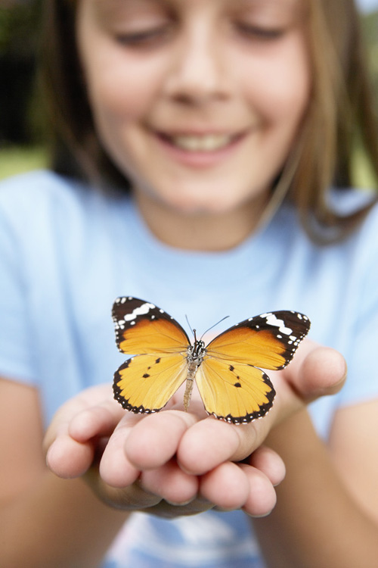

###### Donec sed sem.?

Vestibulum porta dictum est. Lorem ipsum dolor sit amet, consectetuer adipiscing elit. Duis hendrerit congue nunc.

###### Sed sit amet lacus?

Cras lacus lorem, fringilla a, adipiscing ut, congue ac, tortor. Sed aliquet vestibulum sem. Class aptent taciti sociosqu ad litora torquent per conubia nostra, per inceptos hymenaeos.

###### Mauris felis?

Pellentesque commodo. Phasellus lacinia, nisi semper pulvinar tincidunt, orci magna ultrices dui, sit amet laoreet nunc nulla eu justo. Cras sed risus euismod velit fermentum condimentum.

Sed

Ipsum Augue?

Mauris nonummy, turpis ac lacinia ultrices, ligula nisl tempor odio, eget viverra dolor massa at lacus. Donec ultrices arcu id massa. Pellentesque vel lectus. Sed at mauris. Nunc facilisis ipsum nec urna. Proin rhoncus, magna eu tristique condimentum, leo justo imperdiet odio, vehicula ultrices enim diam et nunc. Sed consequat ultricies nunc. Mauris nulla. Nam sem nisi, fringilla semper, tristique id, cursus vel, pede. Nunc lacus. Sed feugiat. Curabitur fringilla justo non nisi. Class aptent taciti sociosqu ad litora torquent per conubia nostra, per inceptos hymenaeos. Vivamus elementum ultrices eros. Fusce diam purus, porta et, ullamcorper a, egestas id, mi. Nullam cursus. Nullam auctor, eros vitae pellentesque fringilla, sem augue dignissim enim, vitae interdum velit lorem ut metus. Duis consectetuer lacus id tellus.

In vehicula malesuada velit. Etiam ante dui, interdum tempor, cursus sit amet, accumsan vitae, tellus. Suspendisse varius sollicitudin nisl. Pellentesque habitant morbi tristique senectus et netus et malesuada fames ac turpis egestas. Donec pretium augue nec dolor. Ut vestibulum. Donec non nisi nec tellus consequat tincidunt. Mauris ultricies nulla. Ut nec augue. Mauris et risus et odio vestibulum lacinia. erat. Cras vestibulum magna nec nisi. Nam semper congue mi.

#### Vivamus nisl.

# Nam orci.

##### Aenean ipsum dui, porta sit amet, viverra nec, placerat vitae, mi. Sed eget metus eu felis convallis congue.Pellentesque rutrum pede ac velit.

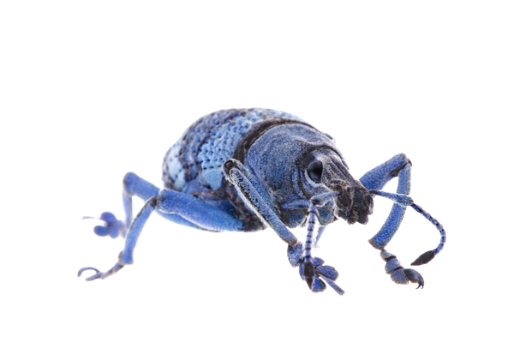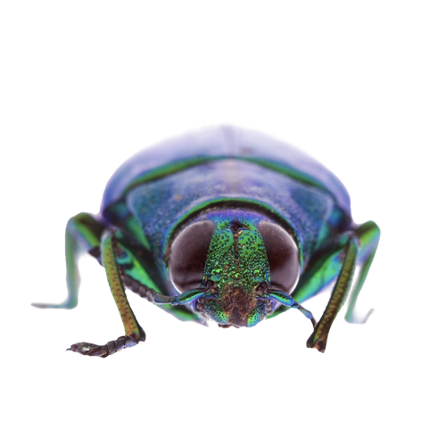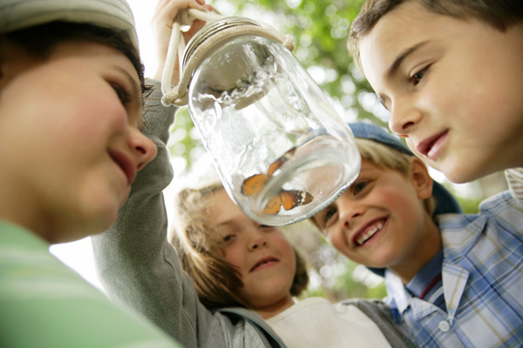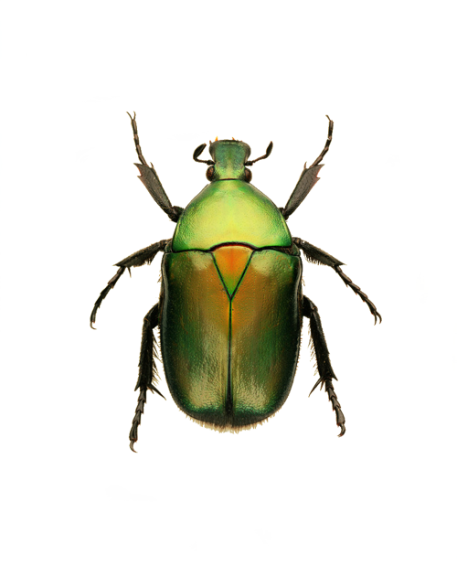

Continued from page 1

Etiam enim.

Quisque interdum turpis accumsan sem. Donec odio mi, dapibus id, mattis rhoncus, semper non, tellus.

Duis volutpat lorem.

Phasellus consequat, ipsum ac scelerisque rutrum, lorem leo eleifend justo, eu vulputate mauris lorem .

Aenean adipiscing tincidunt ante.

Suspendisse luctus, mi eget suscipit nonummy, ligula urna pellentesque lorem, a sodales nisl eros at est.

Cras sit amet quam nec nisl viverra tempus?

Lorem ipsum dolor sit amet, consectetuer adipiscing elit. Integer et lorem vitae orci auctor dapibus.

Nullam tempor liberoPhasellus pulvinar, velit in interdum ultricies, ipsum diam sodales augue, in ornare metus tellus id metus. Sed bibendum semper ligula. Nulla facilisi. Duis iaculis nisl vitae eros. Proin hendrerit.

Non leo:

The first day of each week a newsletter like this one will come home. It is designed to keep you informed of our academic goals for the week, important dates coming up, and any other pertinent information you may need. Please make sure to check your child’s go home folder for this and other important papers.

Tonight you have several district forms coming home with your child. These include:

* Field trip permit
* Online access authorization
* Publicity release form
* Health information update

Please fill these out and return them to school as soon as possible.

Tomorrow you will receive my classroom information guide. In it you will find useful information to help you know my curriculum, my behavior policy, etc. You can also find this information out by visiting my website:

mrssarbackers2ndgrade@weebly.com.

(Continued)



[Issue] :: [Date]

LoremIpsumDolor

Fusce eget nibh. Maecenas commodo ipsum non urna. Vivamus bibendum fermentum pede. Vestibulum eu dolor. Vestibulum ligula magna, gravida vitae, malesuada et, tincidunt non, elit. Cum sociis natoque penatibus et magnis dis parturient montes, nascetur ridiculus mus. Phasellus pulvinar, nibh fringilla porta vulputate, nibh justo imperdiet mi, ut ultricies sem lectus ut leo. Phasellus nisl turpis, venenatis et, imperdiet eget, viverra id, lorem.

Cras fermentum dolor id ante. Nullam elementum, orci vitae semper pellentesque, turpis lectus posuere lacus, in pharetra justo odio vel ipsum. Vivamus aliquam sagittis arcu. Cras nonummy tristique elit. Aliquam id augue vel nibh fringilla placerat. Fusce sed eros. Duis consectetuer est at mauris.

Dolor sit amet.

[Street Address]  
[City], [State][Postal Code]

[Web Address]

Address Line 1  
Address Line 2  
Address Line 3  
Address Line 4

[Recipient]

Lorem Ipsum

Dolor